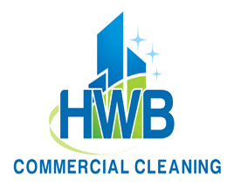

Capability Statement 2025

ABOUT US
It’s not just about cleaning anymore; It is about the human experience that we all depend upon. We know what to do, how to do it and why we are here. HWB is commercial cleaning company providing complete janitorial custodial services to clients in the private and public sector. We operate in the DFW Metroplex and the entire State of Texas. Integrity, communication, attention to detail are our company values.

CORE COMPETENCIES
- Client satisfacton driven | - Fast problem resolution
- Year round staff training | - Cost control
- Green cleaning practices | - Commercial/industrial safety programs
- Technology driven supervision | - 24/7 cleaning operations

PAST PERFORMANCES  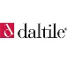 
- 6,000,000 sq.ft. of commercial/academic/industrial space cleaned.
- 150,000 sq. ft. of strip and wax floor completed.
- 3 academic facility disinfection programs setup.
- 2 Industrial safety department program created for clients.
- 35 new crews trained/updated on SOP official documents.

DIFFERENTIATORS
- Crews hired live within 5 to 10 minutes of client mitigating absentee levels due to weather inclement or travel problems.
- Personal supervisor assigned to accounts.
- Use of sustainable products, processes and green programs.
- We do what we say we are going to do. Period.

HWB Cleaning Services LLC.
Mirna Rondinella
President
Humberto Dominguez
Chief Executive Officer

3342 FM 1827 Ste 8d
McKinney, TX 75071
Office: 214-586-0257

Corporate Information
Texas LLC Charter #: 802920409
Federal Tax ID #: 82-4377459
Sales Tax ID#: 32005785756
DUNS: 08-283-0635
Commercial insurance
Policy #: GHF000742
Current experience rate (EMR) # .43
Insurance Risk Consultants
Agent: Carlos Aguirre
682-667-3863
Industrial codes:
SIC: 7349-01 Janitorial Services
NAICS: 561720 Janitorial Services
UNSPSC: 7611 Cleaning & Janitorial S.
Federal Government
CAGE (SAM) #: 082830635

